Corey Gaspar
1/21/2026
3-1 Milestone: Database Indexing and Authentication
Part I: Importing and Indexing a Data Set
First, I navigated to the datasets folder in Codio and then imported the AAC Shelter Outcomes CSV file into MongoDB using mongoimport. I made sure that I included the AAC database and the animals collection in the command. 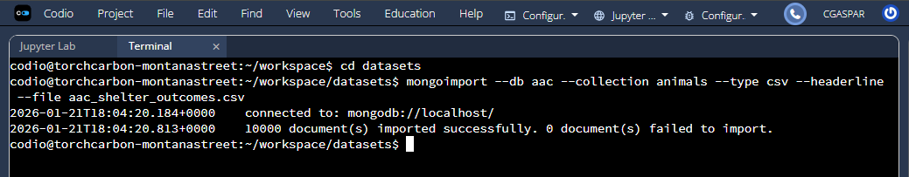
After the CSV file was imported, I started the Mongo Shell by using mongosh.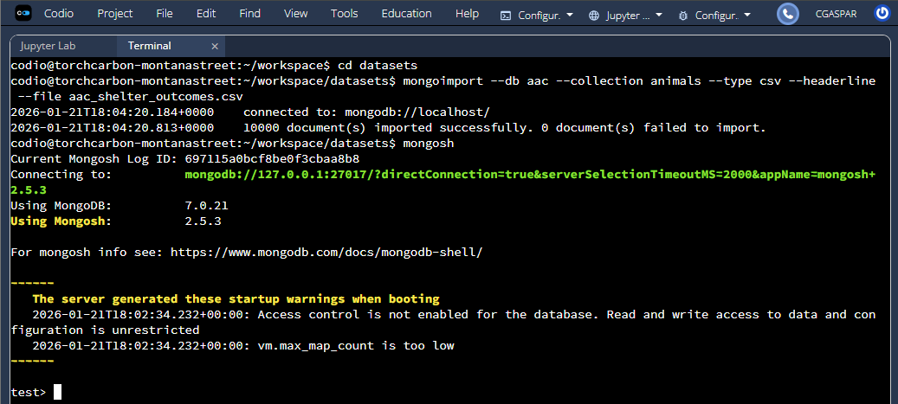

In the Mongo Shell, I ran “show dbs” to show all databases and ran “use aac” to use the AAC database. Then, I created an index on the breed field. 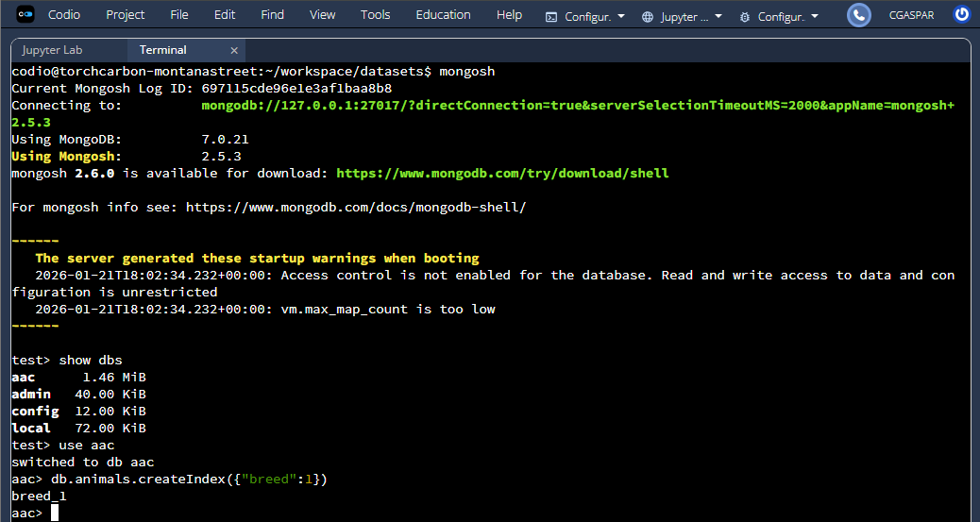

I ran “db.animals.find” to find all entries where the breed is Border Collie Mix.
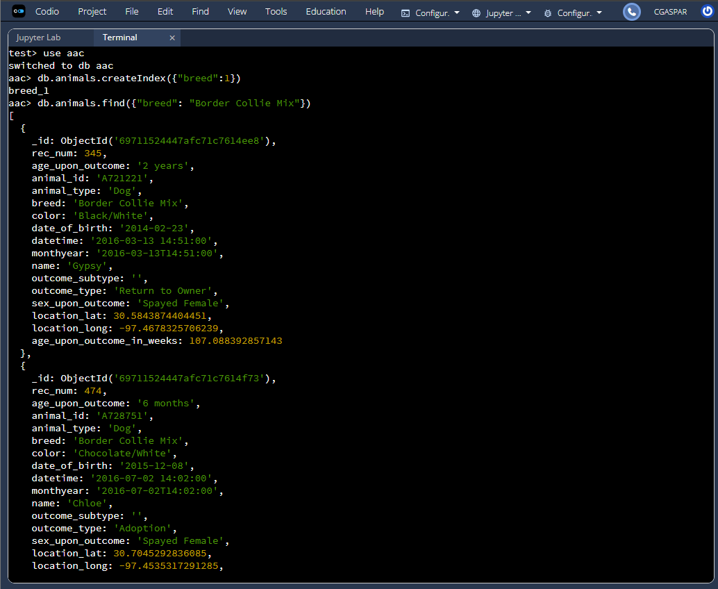

I ran the same command, except this time I used the explain function to verify that the index is being used.
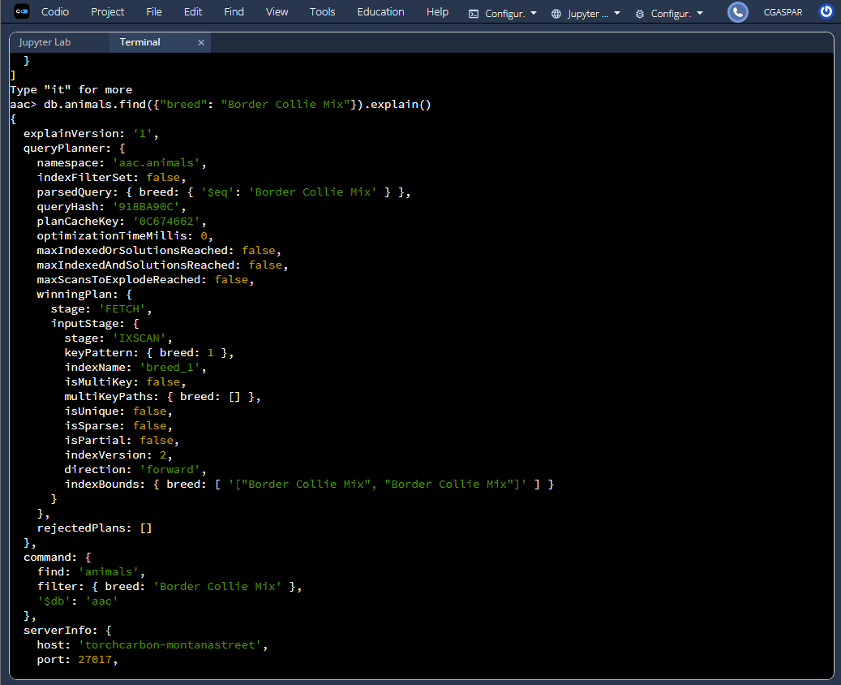

I created a compound index on breed and outcome_type and ran a query using the explain function to verify that the index was being used. (Screenshot continued on next page.)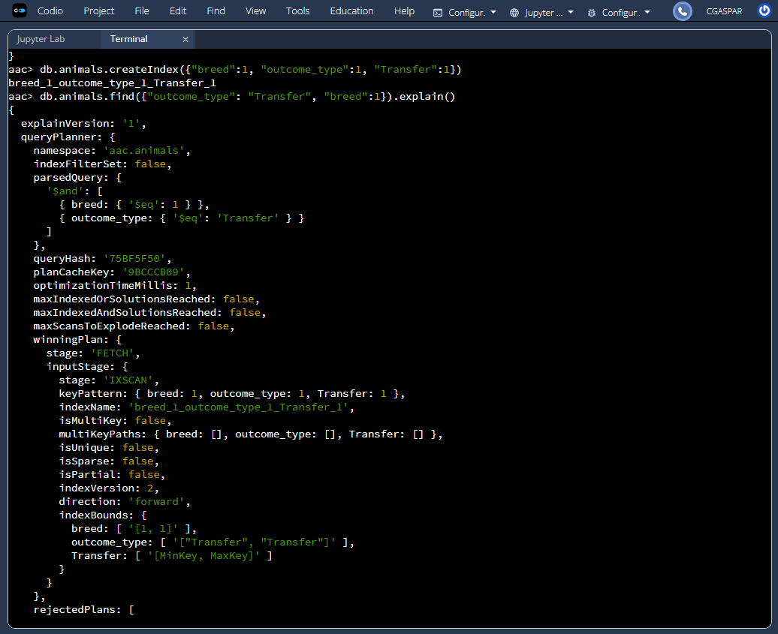

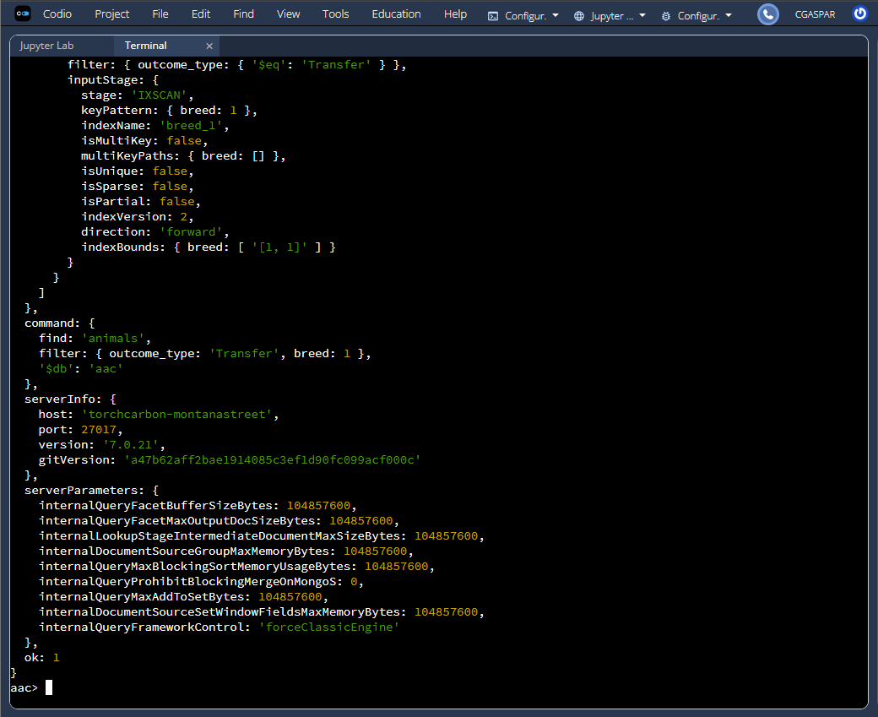

Part II: User Authentication
I connected back into the Mongo Shell using the mongosh command, ran “show dbs” to get a list of all databases, and switched to the admin database. I then used “db.createUser” to create the new aacuser account with a password and read/write permissions in the AAC database. I then ran “db.getUsers” to ensure that the account was created properly.
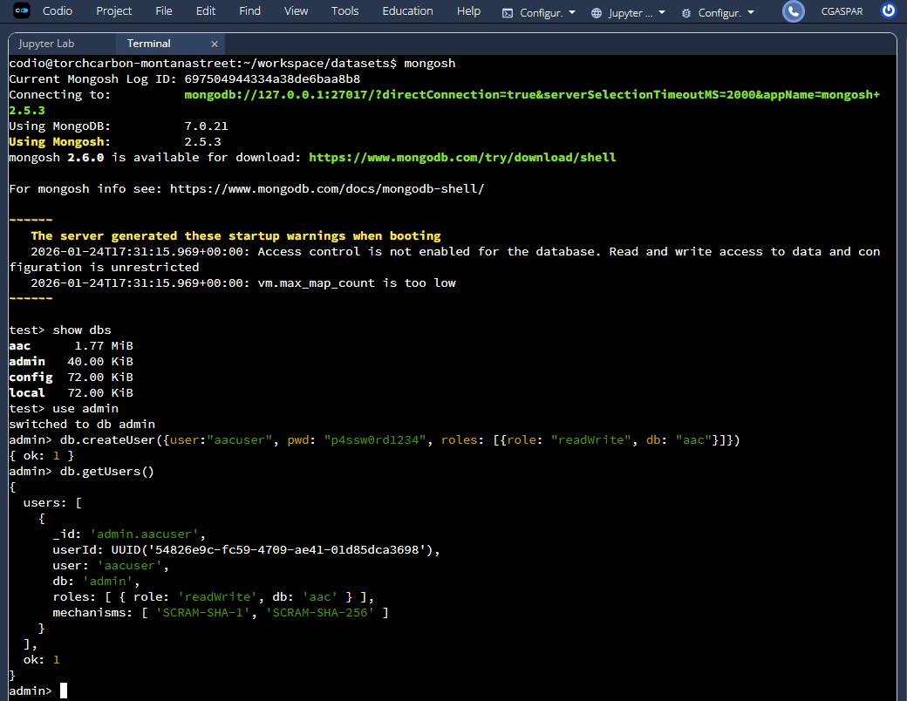

After the account was created, I exited the shell and reopened it, but this time I used the new username and password to sign in. I then ran “db.runCommand({connectionStatus: 1})” to ensure that the authentication was successful.
